Programme 7/8/9/10 October 2010

Thursday 7th October 2010

TRAINING COURSE FOR ALL RETRIEVERS
Meeting at 09.00

BEGINNERS CLASS ( for dogs of any age: from basic education to their first retrieving)

INTERMEDIATE CLASS (dogs with good education and a good level of retrieving training)

ADVANCED CLASS (dogs with an excellent retrieving training)

Intructors : Mr Mervyn Philpott (GB)
Mr Rony Michiels (B)
Mrs Moira Frank (I)

Cost 40 euros for members / 50,00 euros for non members

SPECIAL PUPPY CLASS:
Reserved to dogs up to 6 months

Intructors :
Mrs Irene Teppa Labrador Retriever
Mr Lorenzo Borretti Golden Retriever
Mr Roberto Marena Flat Coated, Nova Scotia DTR, CCR, CBR

Cost 30,00 euros- members / 40,00 euros - non members

Friday 8th October 2010

WORKING TEST OPEN TO ALL RETRIEVERS (with Speciality for Veteran subjects)

ABSOLUTE BEGINNERS – BEGINNERS – NOVICE – OPEN Classes & NON COMPETITIVE CLASS
(RULES ON http://www.retrieversclub.it/lavoro/Regolamenti/CircuitoWorkingTest.aspx)
VETERAN CLASS: this class is reserved to the subjects over 8 years of age (provided that more than 5 ones are entered).
Combine event (Working Test and Club Show)
Secretary from 7.30
Working test from h. 8.00

Judges: Mrs Moira Frank (I)
Mr Rony Michiels (B)
Mr Philippe Lammens (F)
Mr Mervyn Philpott (GB)

Cost for members 40,00 euros - first dog - 35,00 - second dog of the same handler
30,00 - third dog of the same handler
Cost for not members 50,00 euros first dog - 45,00 - second dog of the same handler
40,00 - third dog of the same handler

To follow in the afternoon :

Grooming and Handling Course for all retriever breeds with a “Handling Final Contest for all Retrievers”

Mrs Laura Lazzaretto Golden Retriever
Mr Antonio Fontana Labrador Retriever
Mrs Susanna Dini Flat Coated, Nova Scotia DTR, CCR, CBR
Cost 35,00 euros

Seminar regarding the techniques and methods for the resolution of primary problems in relation to reproduction, coupling and selection, and neo natal problems.
Vet.Dr. Luca Chiri

“STIMULATING PUPS and THE PUP ARRIVES AT HIS NEW HOME” : what is necessary to welcome the new arrival, and the correct advice for his first year.
Vet. Dr. Sabrina Gasparri

Social Dinner at the Hotel Royal restaurant at 21.00

WORKING TEST AWARDS
During the social dinner the Working Test winners will be awarded the prizes

Saturday 9th October 2010

SPECIALITY SHOW in the park of Tabiano Bagni, that will be combined with the Working Test.
Meeting time 8.30
Judging will start at 10.00

LABRADOR RETRIEVER Judges : Mr Philippe Lammens (F) BITCHES & BOB
Sig. Nicola Imbimbo (I) DOGS

GOLDEN RETRIEVER Judges : Mr Marvyn Philpot (GB) DOGS & BOB
Mr Gianni Guffanti (I) BITCHES

FLAT COATED, NOVA SCOTIA DTR,CCR,CBR
Judge : Mrs Sonia Falletti Ballan (I) ALL GROUP

Official photographers for the Event:
Mrs Jadranka & Mr Jan - DEYA Photography www.deya-online.com

L’ENOVA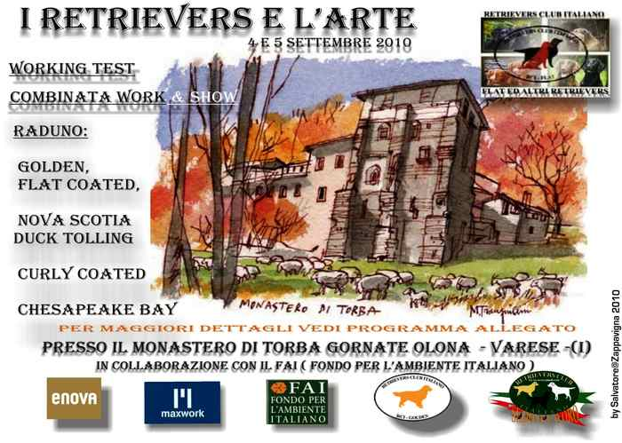offers the trip to CRUFT’S 2011 to the winner of the BIS

AWARDS for COMBINE WORK&SHOW : at the end of the Specialità Show, prizes will be awarded to the dogs that take part in both events, according to the list of the sum of both results obtained.. Every dog entered will receive a Certificate of Participation.

In THE EVENING. At the “Grancaffè” of the Theatre, a BENEFICENCE GALA will take place to the benefit of the less fortunate dogs. Its attraction will be THE PARADE OF CHAMPIONS, comprising also the winners of RCI Titles and Challenges; also available the BLUE BOOK containing all information as to obtain the various Titles.
During the event, there will be a BENEFICENCE AUCTION SALE of objects offered by RCI and anybody else (that are gently required to inform the organisers, sending a photo of the objects offered).

WORKING TEST CORCUIT AWARDS 2010
During the social dinner we shall also award the prizes of the Working Test Circuit 2010

SUNDAY 10th October 2010

FIELD TRIAL French style

Judges: PHILIPPE LAMMENS (F)
RONY MICHIELS (B)
MOIRA FRANK (I)
BEPPE MASIA (I)

PHOTOGRAPHIC STAGE for your dogs held by
Mrs Jadranka DEYA Photography www.deya-online.com

OCULISTIC VISITS held by Dr. Mauro Cervia

MONDAY 11th October 2010

FIELD TRIAL English Style

Judges: PHILIPPE LAMMENS (F)
RONY MICHIELS (B)
MOIRA FRANK (I)
BEPPE MASIA (I)

+

